Notepad++ Setup Roger Pfister http://rogerpf.com/aaBridge

If you are running a MAC then the recommend editor for use with aaBridge is
https://www.barebones.com/products/bbedit/ BBEdit
You DO NOT need the pay for features – take the 'free trial' and let the trial run out so you will just have the free features – they won't mind.

If you are running Windows then the recommendation is Notepad++

https://notepad-plus-plus.org/
The remainder of the is document is advice as to how best to configure (setup) Notepad++ to work well with aaBridge.

Recommendations

A. Install the 32 bit version of Notepad++ even on 64 bit windows machines. The 32 bit version runs fine on 64 bit Win 10 and has a better plugin manger and a better range of plugins.

B. Install Notepad++ to the folder
C:\ProgramSmall\Notepad++
While not essential for English Language computers BUT needed for others as it allows aaBridge to easily find Notepad++ and so show that an editor is available by displaying the Pencil Icon in the top left area.
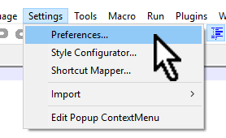
The following setting are all accessed via Menubar > Settings > Preferences
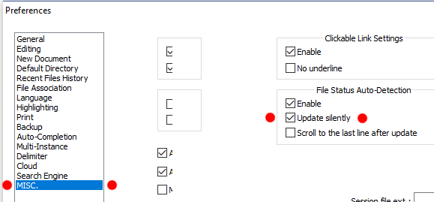
C. Under MISC. - File Status Auto-Detection check Enable & Update silently

These means you will only be interrupted by "this file has changed messages" when such changes would override your own recent changes.

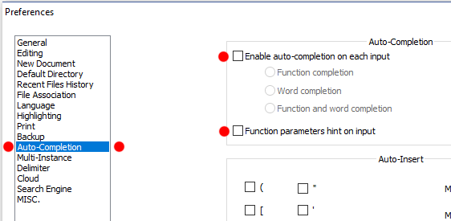
D. Under Auto-Completion TURN OFF (uncheck) Auto-Completion

If you leave it on it will drive you mad. :)

E. in the Menubar click View then select Word Wrap in the menu.
Word Wrap will then show a Check Mark (tick).

<end document>

